Project Development Phase
Model Performance Test
Date | 08 October 2026
Team ID | SWTID-2026-1916
Project Name | Implement Client Script & UI Policy (Incident)
Maximum Marks
Model Performance Testing:
Performance and functional validation results for the ServiceNow UI Policy and Client Script implementation on the Incident table.
S.No. | Parameter | Values | Screenshot
1 | Configuration Summary | ServiceNow Incident form controls: UI Policy "High Impact Control" (Impact = 1 - High) makes Assignment group mandatory and Urgency read-only, with Reverse if false enabled; onChange script auto-sets Urgency; onSubmit script blocks save when Assigned to is empty for High impact; onCellEdit script blocks State edits from the list. | 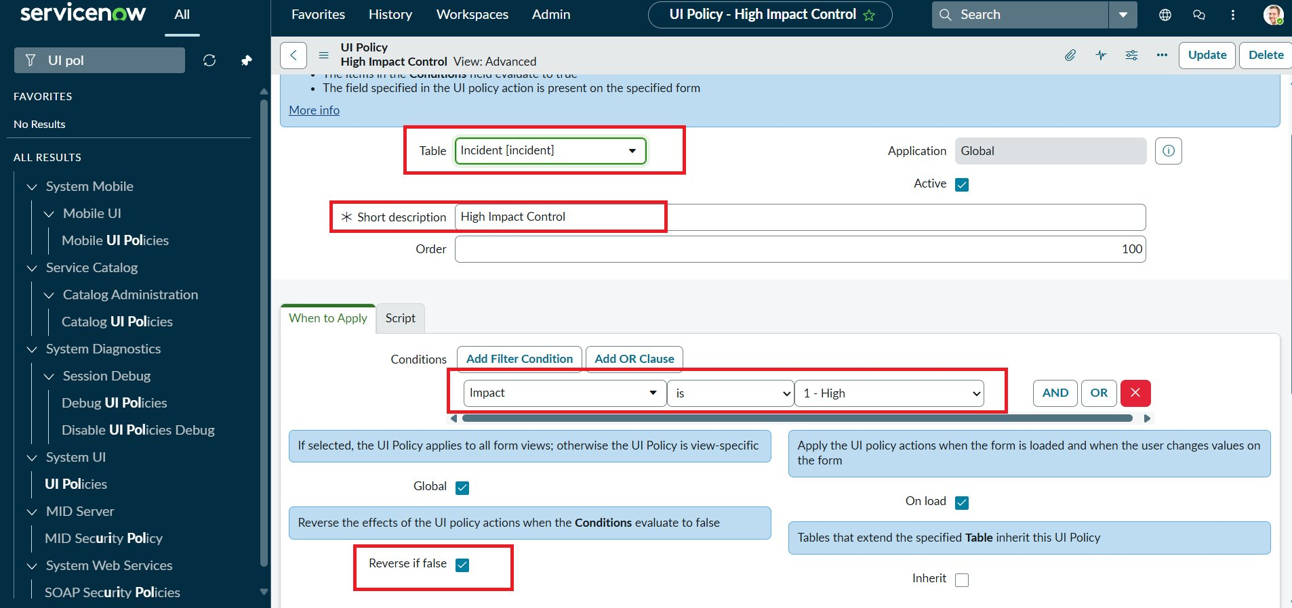  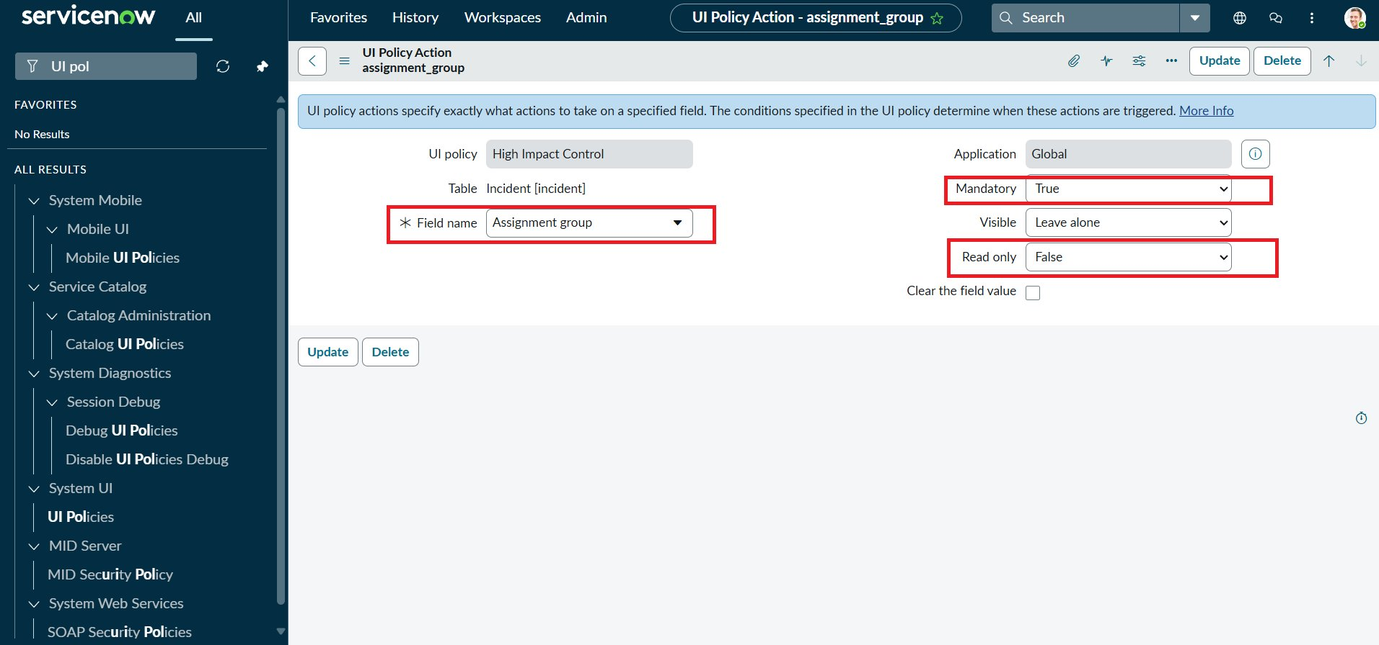
2 | UI Policy Action - Assignment group | Mandatory = True, Read only = False when Impact = High. Reverted automatically when condition is false.
3 | UI Policy Action - Urgency | Read only = True, Visible = Leave alone. Urgency locked when Impact = High; editable again after Impact changes. | 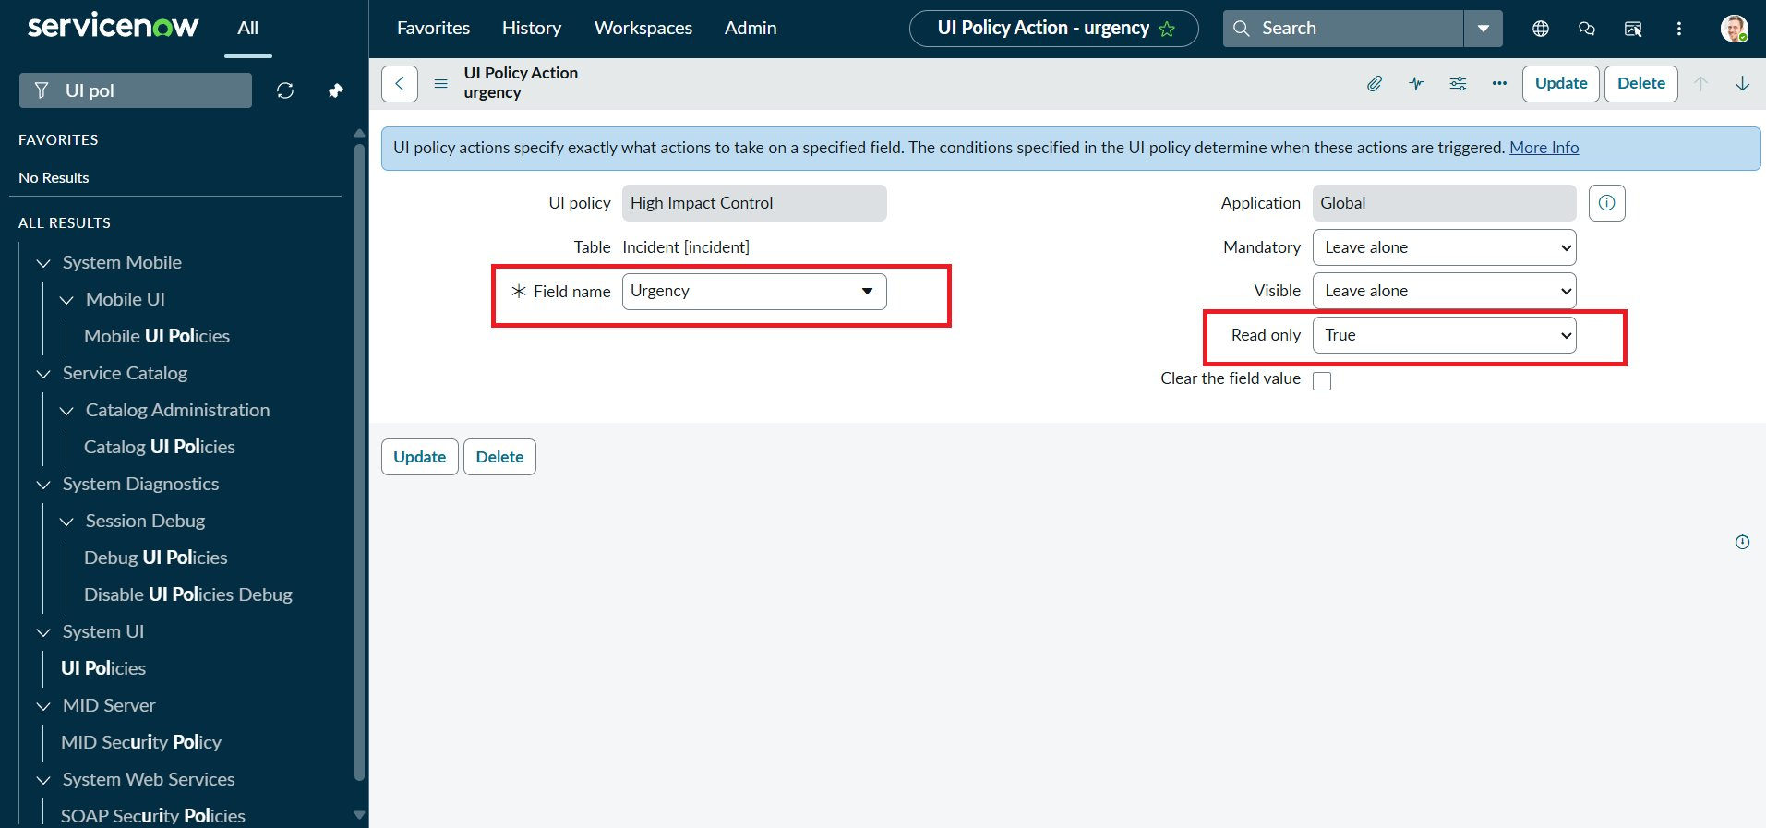
4 | Client Script - onChange (Impact) | Sets Urgency to 1 - High and shows an info message when Impact = 1 - High. | 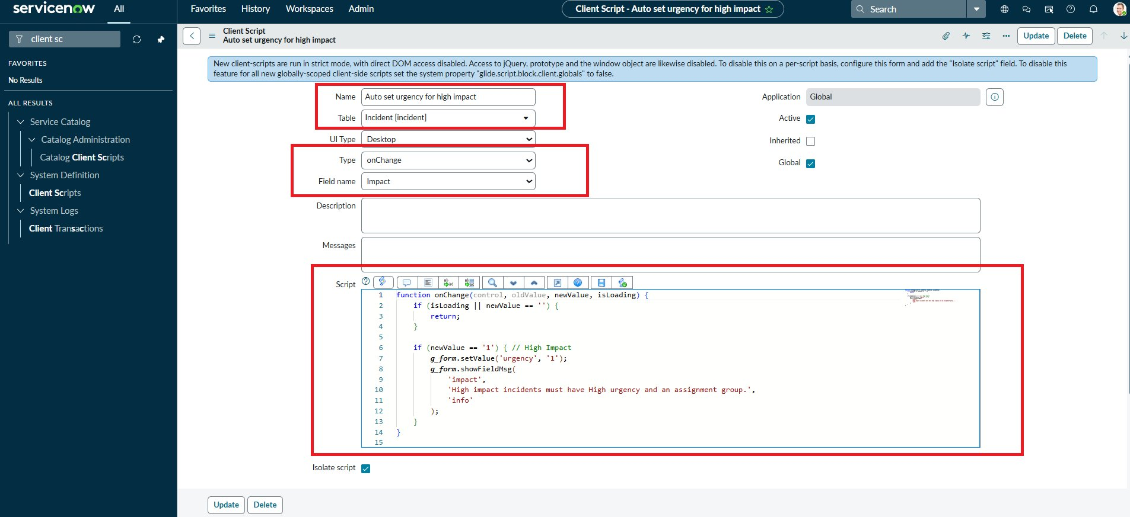
5 | Client Script - onSubmit (Save validation) | Save is blocked with the error "Assigned To is mandatory for High impact incidents." when Impact is High and Assigned to is empty. Save succeeds once a user is selected. Test result: Pass (2 of 2 scenarios). | 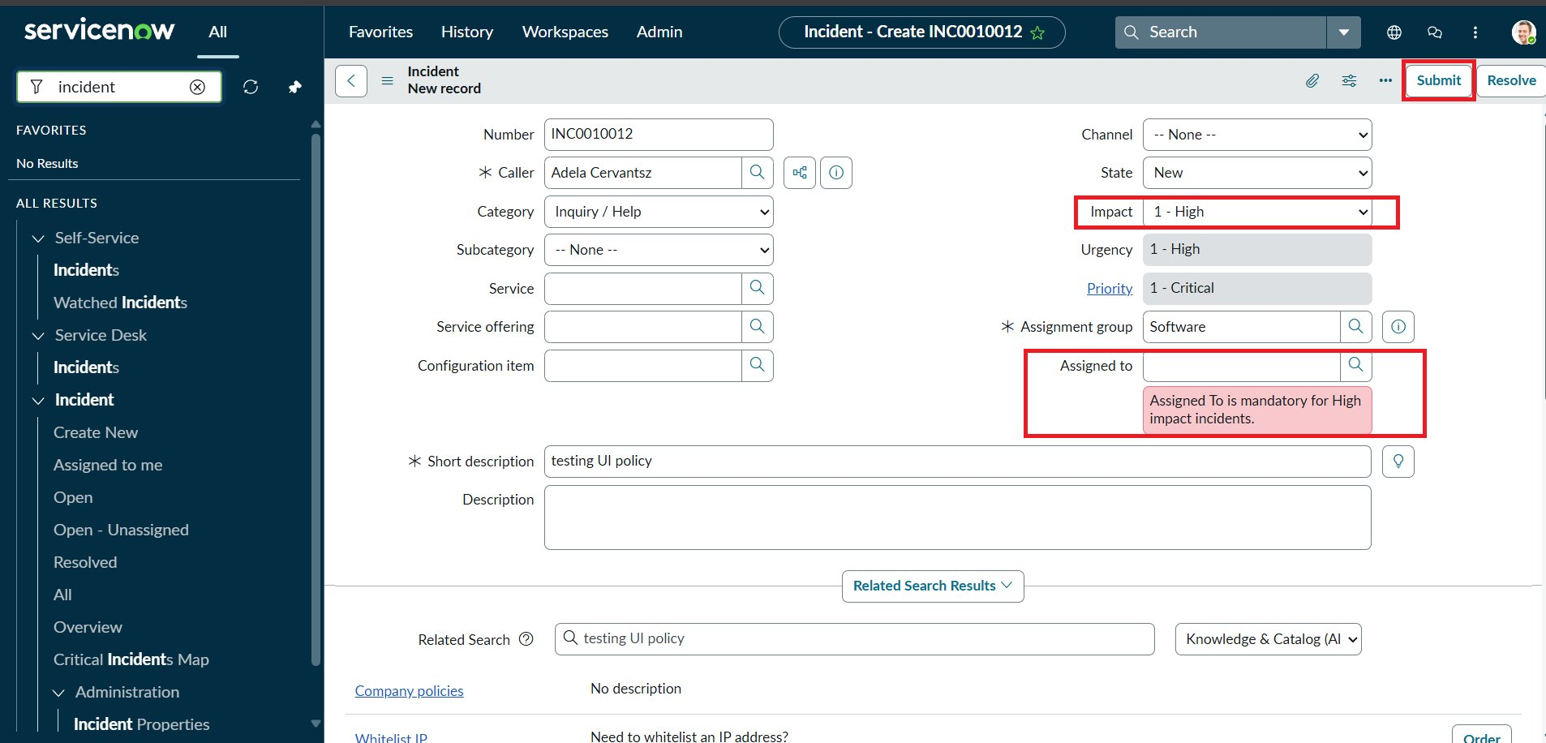  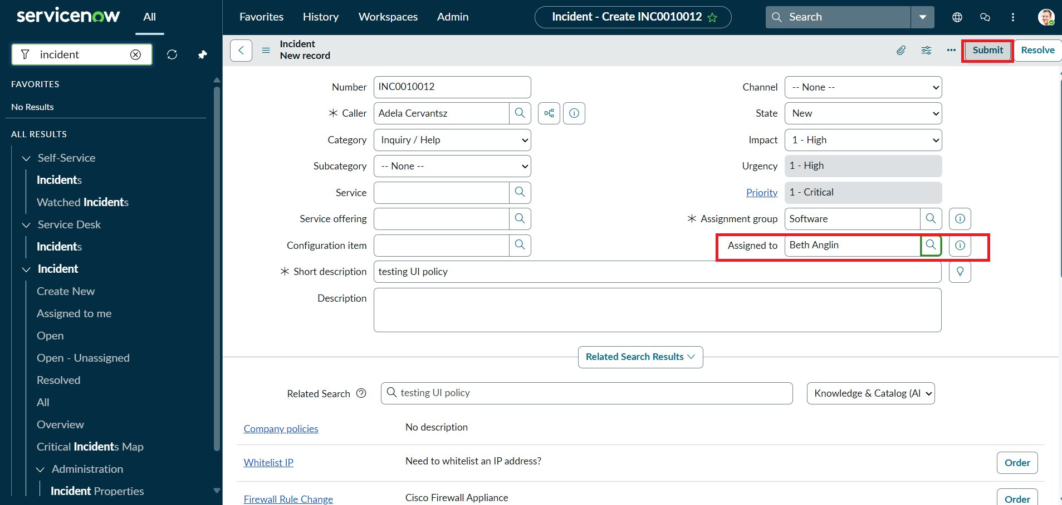
6 | Client Script - onCellEdit (State) | Alert "State cannot be changed from the list. Please open the Incident." is shown and the list edit is cancelled. State changes through the form still save. Test result: Pass (2 of 2 scenarios). | 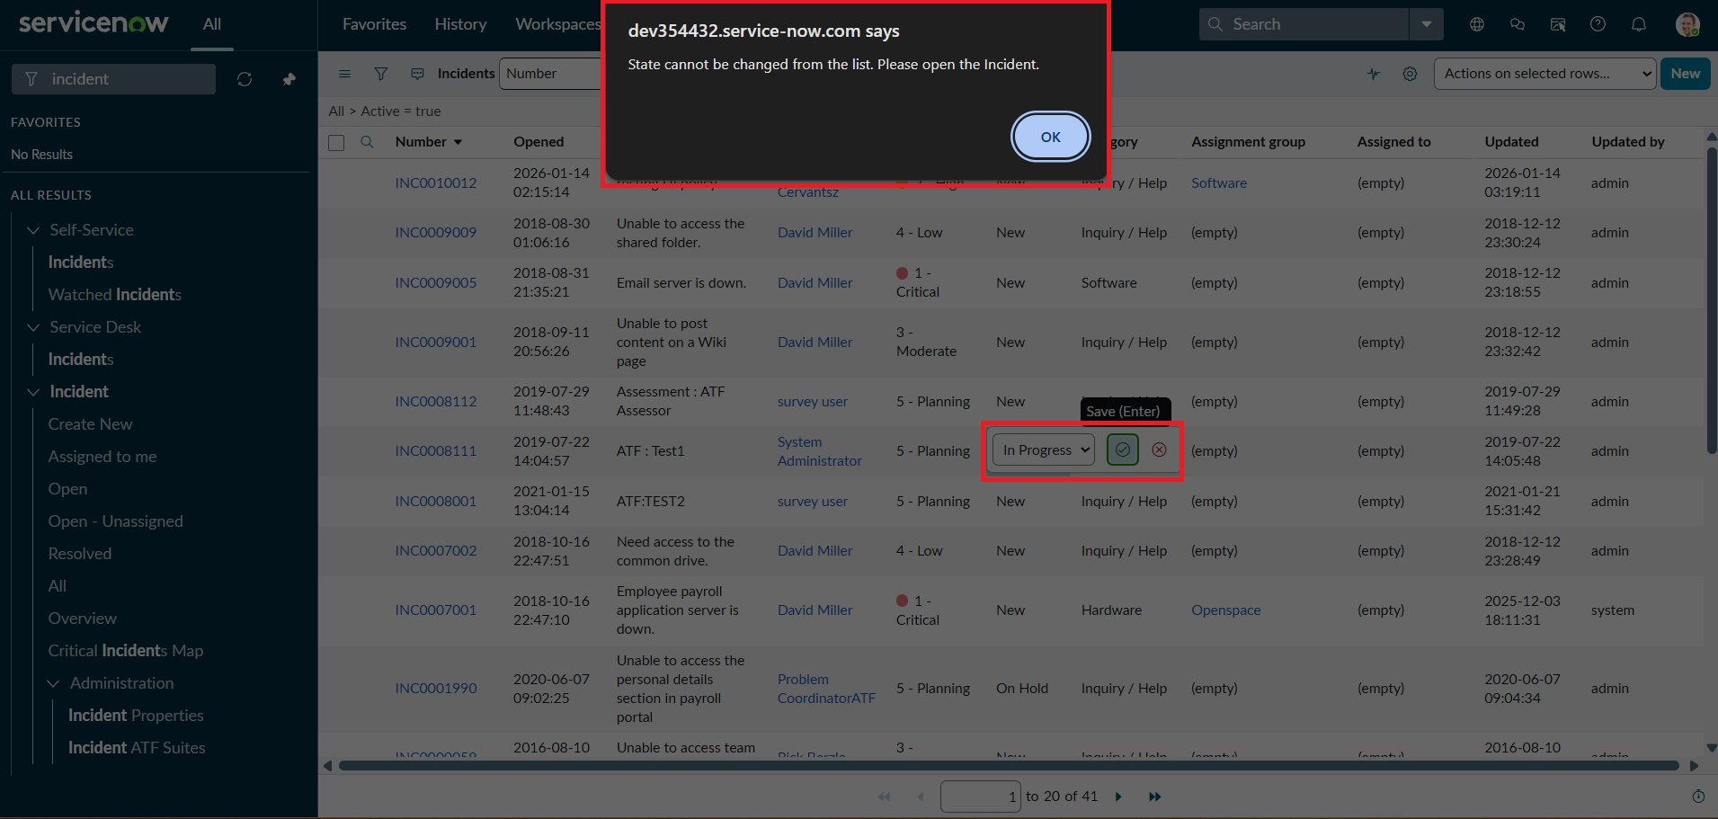  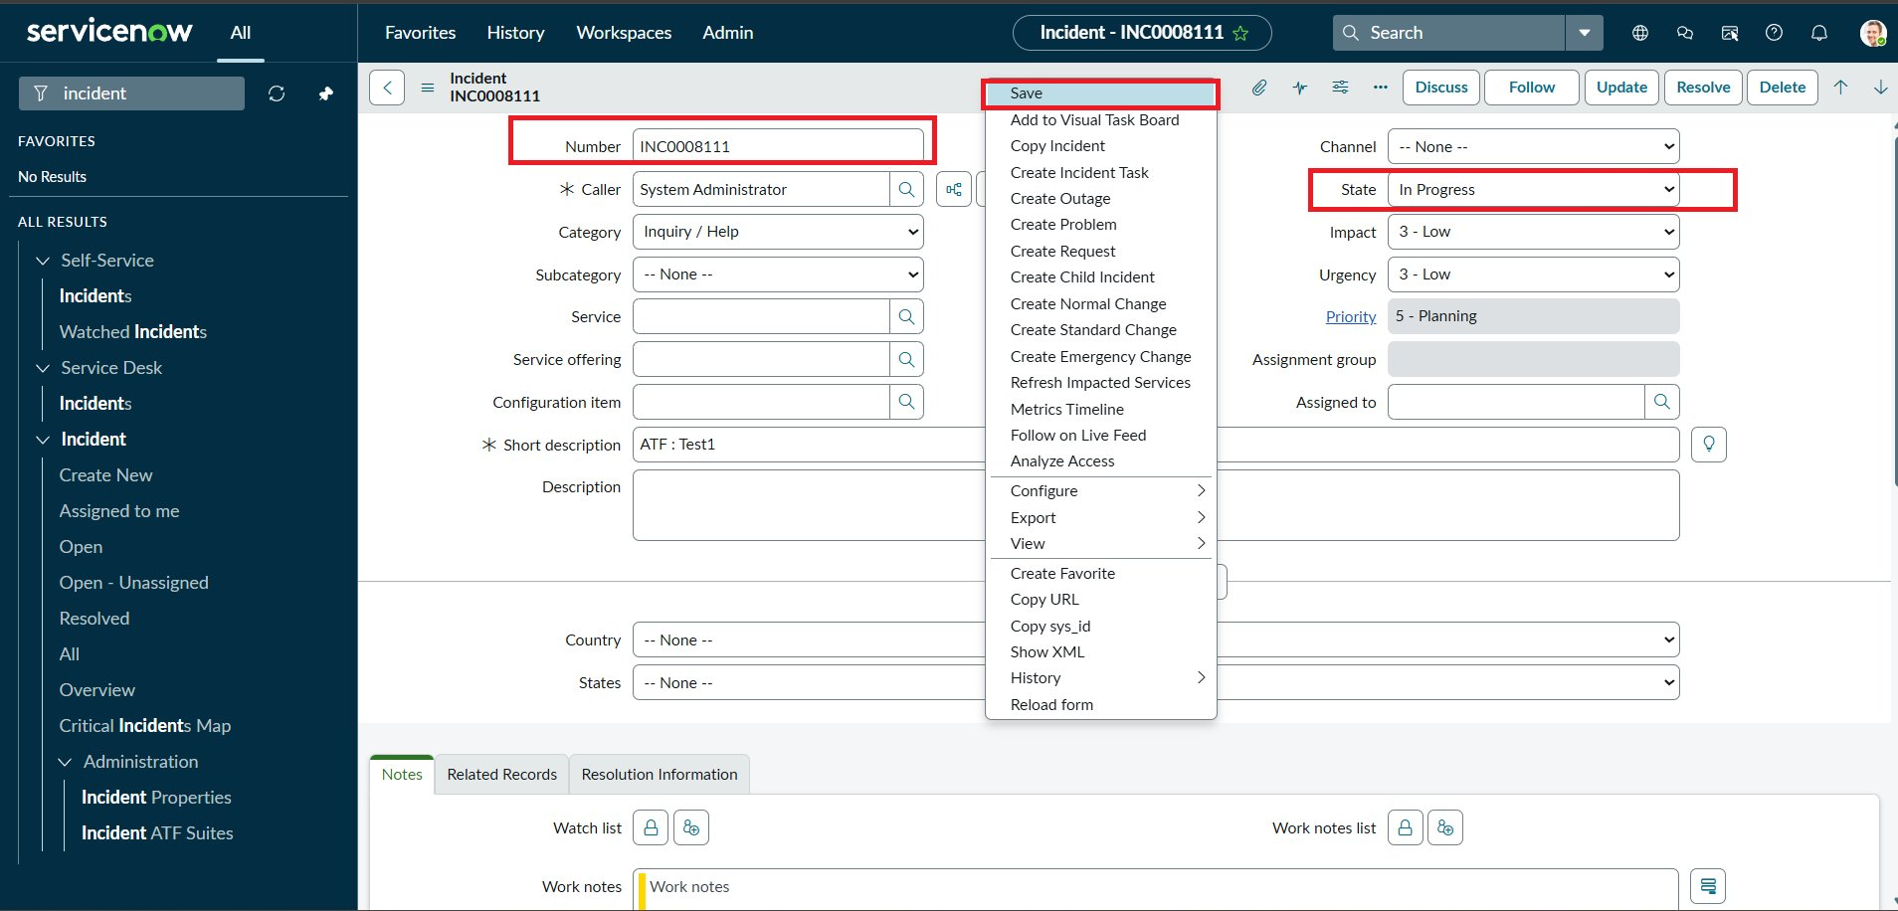
7 | Test Accuracy | Functional test pass rate: 100% (8 of 8 UAT test cases passed; see UAT document). Reverse condition (Impact High to Medium) verified. | 